Hugo Pelayo
English Course – DAM
January 30 2024

Exercise 4
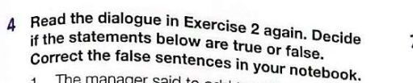

1. The manager said to add together all the prices to get the final purchase price. (False). You multiply the number of items/parts purchased by the price.
2. The new employee needs to write the formula into each cell. (False). You just copy and paste the price formula into each cell.
3. It is possible to sort a list by more than one category. (True)
4. The new employee wants all products of the same type placed in one group from the last date purchased. (False). The new employee wants them grouped by the first date purchased in ascending order.
5. The manager explains how to use a formula to find total. (True)

Exercise 5
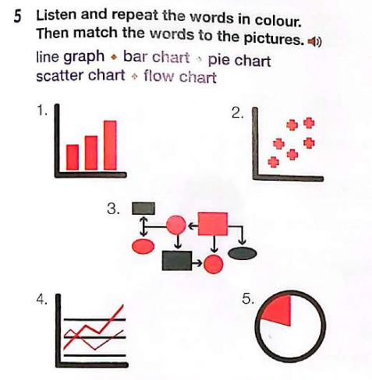

1. Bar chart
2. Scatter chart
3. Flow chart
4. Line graph
5. Pie chart

Exercise 6
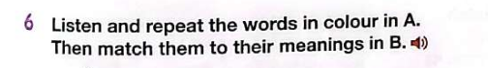

1. worksheet → d. another name for a spreadsheet.
2. format → c. the way information is arranged on a computer.
3. ascending → g. going from the lowest to the highest.
4. group together → e. put similar items in the same category.
5. purchase price → a. the amount you pay for a product.
6. descending → b. going from the highest to the lowest.
7. according to → f. as indicated by.

Exercise 7


1. If you want to separate something into equal parts, you will divide it.
2. When you fill a box, you are inserting something into it.
3. The sum is the total numbers of items.
4. Average means the typical or normal amount in a group.
5. Subtract means to take away an amount in order to calculate the difference.

Exercise 8
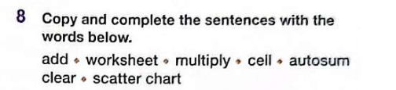

1. Autosum is a function in a spreadsheet that gives you the total of all the numbers you select in a column.
2. If you want to increase a number five times, you will multiply it by five.
3. The first cell in a spreadsheet is always labeled A1.
4. A scatter chart shows the distribution of all the pieces of data.
5. When you add two or more numbers together, you get the total.
6. A worksheet is a file that displays data in rows and columns.
7. Clear means to empty or take something away.

